The Extended Concise LCD Data Sheet for HD44780
Version: 25.6.1999

Instruction | RS | RW | D7 | D6 |  | D5 | D4 | D3 | D2 | D1 |  | D0 |  | Description |  |  | Clock-  Cycles
NOP | 0 | 0 | 0 | 0 |  | 0 | 0 | 0 | 0 | 0 |  | 0 |  | No Operation |  |  | 0
Clear Display | 0 | 0 | 0 | 0 |  | 0 | 0 | 0 | 0 | 0 |  | 1 |  | Clear display & set address counter to zero |  |  | 165
Cursor Home | 0 | 0 | 0 | 0 |  | 0 | 0 | 0 | 0 | 1 |  | x |  | Set adress counter to zero, return shifted display to original position.  DD RAM contents remains unchanged. |  |  | 3
Entry Mode Set | 0 | 0 | 0 | 0 |  | 0 | 0 | 0 | 1 | I/D |  | S |  | Set cursor move direction (I/D) and specify automatic display shift (S). |  |  | 3
Display Control | 0 | 0 | 0 | 0 |  | 0 | 0 | 1 | D | C |  | B |  | Turn display (D), cursor on/off (C), and cursor blinking (B). |  |  | 3
Cursor / Display shift | 0 | 0 | 0 | 0 |  | 0 | 1 | S/C | R/L | x |  | x |  | Shift display or move cursor (S/C) and specify direction (R/L). |  |  | 3
Function Set | 0 | 0 | 0 | 0 |  | 1 | DL | N | F | x |  | x |  | Set interface data width (DL), number of display lines (N) and character font (F). |  |  | 3
Set CGRAM Address | 0 | 0 | 0 | 1 | CGRAM Address |  |  |  |  |  |  |  |  |  | Set CGRAM address. CGRAM data is sent afterwards. |  | 3
Set DDRAM Address | 0 | 0 | 1 | DDRAM Address |  |  |  |  |  |  |  |  |  |  | Set DDRAM address. DDRAM data is sent afterwards. |  | 3
Busy Flag & Address | 0 | 1 | BF | Address Counter |  |  |  |  |  |  |  |  |  |  | Read busy flag (BF) and address counter |  | 0
Write Data | 1 | 0 | Data |  |  |  |  |  |  |  |  |  |  |  | Write data into DDRAM or CGRAM |  | 3
Read Data | 1 | 1 | Data |  |  |  |  |  |  |  |  |  |  |  | Read data from DDRAM or CGRAM |  | 3
x : Don't care | I/D | 1  0 | Increment  Decrement |  |  |  |  |  |  |  | R/L |  | 1  0 |  |  | Shift to the right  Shift to the left
x : Don't care | S | 1  0 | Automatic display shift |  |  |  |  |  |  |  | DL |  | 1  0 |  |  | 8 bit interface  4 bit interface
x : Don't care | D | 1  0 | Display ON  Display OFF |  |  |  |  |  |  |  | N |  | 1  0 |  |  | 2 lines  1 line
x : Don't care | C | 1  0 | Cursor ON  Cursor OFF |  |  |  |  |  |  |  | F |  | 1  0 |  |  | 5x10 dots  5x7 dots
x : Don't care | B | 1  0 | Cursor blinking |  |  |  |  |  |  |  | DDRAM : Display Data RAM  CGRAM : Character Generator RAM
x : Don't care | S/C | 1  0 | Display shift  Cursor move

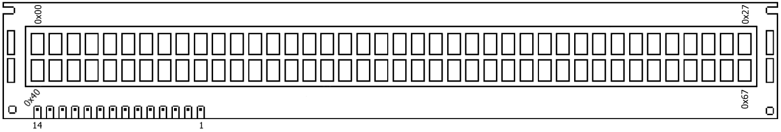
LCD Display with 2 lines x 40 characters :

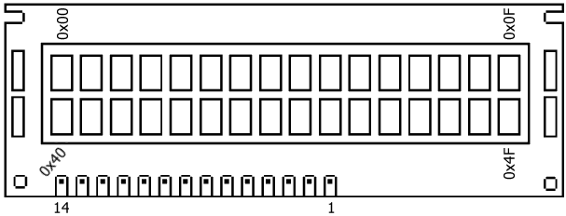
LCD Display with 2 lines x 16 characters :

Pin No | Name | Function | Description
1 | Vss | Power | GND
2 | Vdd | Power | + 5 V
3 | Vee | Contrast Adj. | (-2) 0 - 5 V
4 | RS | Command | Register Select
5 | R/W | Command | Read / Write
6 | E | Command | Enable (Strobe)
7 | D0 | I/O | Data LSB
8 | D1 | I/O | Data
9 | D2 | I/O | Data
10 | D3 | I/O | Data
11 | D4 | I/O | Data
12 | D5 | I/O | Data
13 | D6 | I/O | Data
14 | D7 | I/O | Data MSB

Bus Timing Characteristics
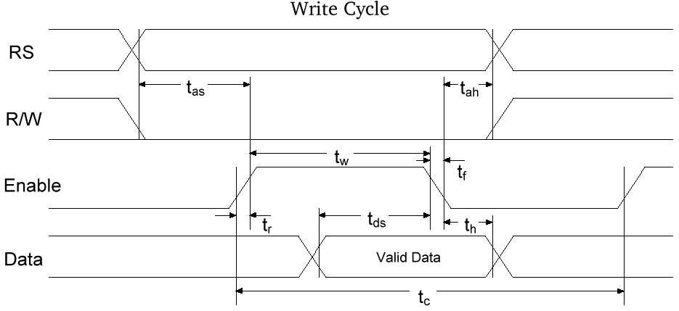
( Ta = - 20 to + 75°C )

Write-Cycle | V_{DD} | 2.7 - 4.5 V ⁽²⁾ | 4.5 - 5.5 V ⁽²⁾ |  | 2.7 - 4.5 V ⁽²⁾ | 4.5 - 5.5 V ⁽²⁾
Parameter | Symbol | Min⁽¹⁾ |  | Typ⁽¹⁾ | Max⁽¹⁾ |  | Unit
Enable Cycle Time | t_{c} | 1000 | 500 | - | - | - | ns
Enable Pulse Width (High) | t_{w} | 450 | 230 | - | - | - | ns
Enable Rise/Fall Time | t_{r}, t_{f} | - | - | - | 25 | 20 | ns
Address Setup Time | t_{as} | 60 | 40 | - | - | - | ns
Address Hold Time | t_{ah} | 20 | 10 | - | - | - | ns
Data Setup Time | t_{ds} | 195 | 80 | - | - | - | ns
Data Hold Time | t_{h} | 10 | 10 | - | - | - | ns
- The above specifications are indications only (based on Hitachi HD44780). Timing will vary from manufacturer to manufacturer.
- Power Supply : HD44780 S : V_{DD} = 4.5 - 5.5 V
HD44780 U : V_{DD} = 2.7 - 5.5 V
This data sheet refers to specifications for the Hitachi HD44780 LCD Driver chip, which is used for most LCD modules.
Common types are : 1 line x 20 characters
2 lines x 16 characters
2 lines x 20 characters
2 lines x 40 characters
4 lines x 20 characters
4 lines x 40 characters
© 1998/1999 by Craig Peacock, Australia http://www.beyondlogic.org
Peter Luethi, Switzerland http://www.electronic-engineering.ch

